GRAPHICAL EVIDENCE SHOWS VACCINES DIDN`T SAVE US
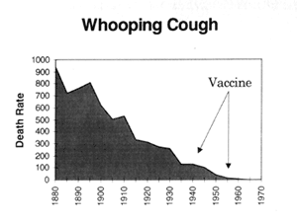 | 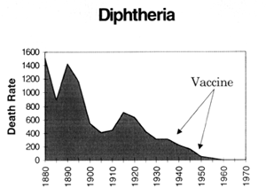
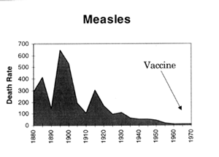 | 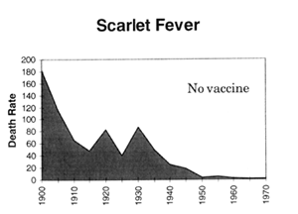
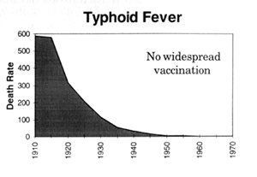 | 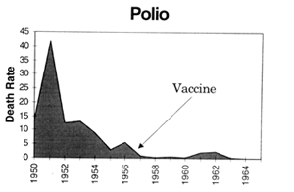

The above graphs, based on the official death numbers as recorded in the Official Year Books of the Commonwealth of Australia, are taken from Greg Beattie`s excellent book "Vaccination A Parent`s Dilemma" and represent the decline in death rates from infectious disease in Australia. They clearly show that vaccines had nothing to do with the decline in death rates. (Note: Graphical evidence on the decline in death rates from infectious disease for USA, England, New Zealand and many other countries shows the exact same scenario as above).
So what were the true reasons for this decline? From his book `Health and Healing` Dr Andrew Weil best answers it with this statement;
"Scientific medicine has taken credit it does not deserve for some advances in health. Most people believe that victory over the infectious diseases of the last century came with the invention of immunizations. In fact, cholera, typhoid, tetanus, diphtheria and whooping cough, etc, were in decline before vaccines for them became available - the result of better methods of sanitation, sewage disposal, and distribution of food and water."

