COST OF DRUGS
Did you ever wonder how much it costs a drug company for the active ingredient in prescription medications? Some people think it must cost a lot, since many drugs sell for more than $2.00 per tablet. We did a search of offshore chemical synthesizers that supply the active ingredients found in drugs approved by the FDA. As we have revealed in past issues of Life Extension, a significant percentage of drugs sold in the United States contain active ingredients made in other countries. In our independent investigation of how much profit drug companies really make, we obtained the actual price of active ingredients used in some of the most popular drugs sold in America.

Celebrex: 100 mg
Consumer price (100 tablets): $130.27
Cost of general active ingredients: $ 0.60
Percent markup: 21,712%
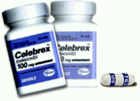
Claritin: 1 0 mg
Consumer Price (100 tablets): $215.17
Cost of general active ingredients: $0.71
Percent markup: 30,306%
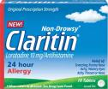
Keflex: 250 mg
Consumer Price (100 tablets): $157.39
Cost of general active ingredients: $1.88
Percent markup: 8,372%
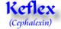

Lipitor: 20 mg
Consumer Price (100 tablets): $272.37
Cost of general active ingredients: $5.80
Percent markup: 4,696%
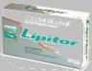
Norvasc: 10 mg
Consumer price (100 tablets): $188.29
Cost of general active ingredients: $0.14
Percent markup: 134,493%
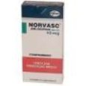
Paxil: 20 mg
Consumer price (100 tablets): $220.27
Cost of general active ingredients: $7.60
Percent markup: 2,898%
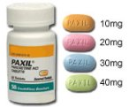
Prevacid: 30 mg
Consumer price (100 tablets): $44.77
Cost of general active ingredients: $1.01
Percent markup: 34,136%
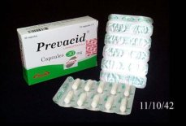
Prilosec: 20 mg
Consumer price (100 tablets): $360.97
Cost of general active ingredients $0.52
Percent markup: 69,417%
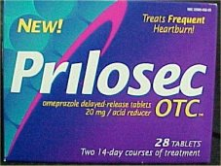
!
Prozac: 20 mg
Consumer price (100 tablets) : $247.47
Cost of general active ingredients: $0.11
Percent markup: 224,973%
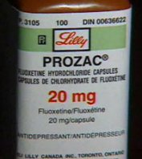
Tenormin: 50 mg
Consumer price (100 tablets): $104.47
Cost of general active ingredients: $0.13
Percent markup: 80,362%
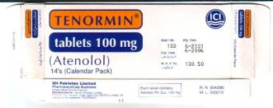
Vasotec: 10 mg
Consumer price (100 tablets): $102.37
Cost of general active ingredients: $0.20
Percent markup: 51,185%
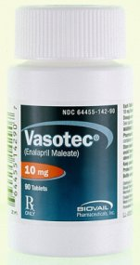
Xanax: 1 mg
Consumer price (100 tablets) : $136.79
Cost of general active ingredients: $0.024
Percent markup: 569,958%
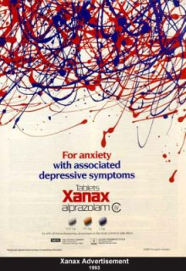
Zestril: 20 mg
Consumer price (100 tablets) $89.89
Cost of general active ingredients $3.20
Percent markup: 2,809
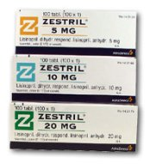
Zithromax: 600 mg
Consumer price (100 tablets): $1,482.19
Cost of general active ingredients: $18.78
Percent markup: 7,892%
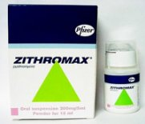
Zocor: 40 mg
Consumer price (100 tablets): $350.27
Cost of general active ingredients: $8.63
Percent markup: 4,059%
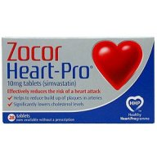
Zoloft: 50 mg
Consumer price: $206.87
Cost of general active ingredients: $1.75
Percent markup: 11,821%
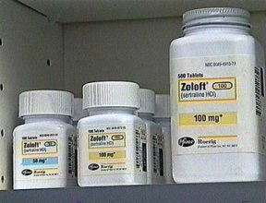

Since the cost of prescription drugs is so outrageous, I thought everyone should know about this. This helps to solve the mystery as to why they can afford to put a Walgreen's on every corner.
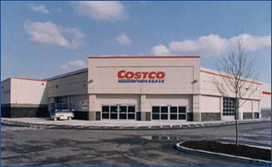
Steve Wilson, an investigative reporter for Channel 7 News in Detroit, did a story on generic drug price gouging by pharmacies. He found in his investigation, that some of these generic drugs were marked up as much as 3,000% or more. Yes, that's not a typo.....three thousand percent! So often, we blame the drug companies for the high cost of
drugs, and usually rightfully so. But in this case, the fault clearly lies with the pharmacies themselves. For example, if you had to buy a prescription drug, and bought the name brand, you might pay $100 for 100 pills. The pharmacist might tell you that if you get the generic equivalent, they would only cost $80, making you think you are "saving" $20. What the pharmacist is not telling you is that those 100 generic pills may have only cost him $10!
At the end of the report, one of the anchors asked Mr. Wilson whether or not there were any pharmacies that did not adhere to this practice, and he said that Costco consistently charged little over their cost for their generic drugs.

I went to the Costco site, where you can look up any drug, and get their online price. It says that the in-store prices are consistent with the online prices. I was appalled.
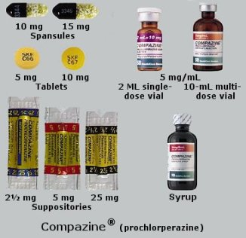
Just to give you one example from my own experience, I had to use the drug, Compazine, which helps prevent nausea in chemo patients.
I used the generic equivalent, which cost $54.99 for 60 pills at CVS. I checked the price at Costco, and I could have bought 100 pills for $19.89. For 145 of my pain pills, I paid $72.57. I could have got 150 at Costco for $28.08.
I would like to mention, that although Costco is a "membership" type store, you do NOT have to be a member to buy prescriptions there, as it is a federally regulated substance. You just tell them at the door that you wish to use the pharmacy, and they will let you in. (this is true)
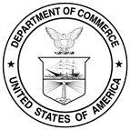
Sharon L. Davis
Budget Analyst
U.S . Department of Commerce
Room 6839
Office Ph: 202-482-4458
Office Fax: 202-482-5480
E-mail Address: sdavis@doc.gov

